Task 1: Manipulate files with CLI

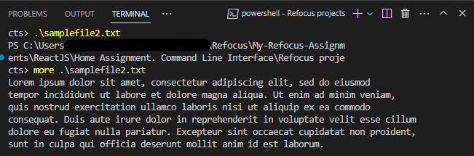

Task 2: Get familiar with Node.js commands

